# INTRODUCTION

Below are instructions on how to take your PublicSchoolWORKS assigned trainings. Your course list will be pre-populated with courses assigned to you. If you have any questions, or need help please call our 24/7 Staff Training Helpline at 1-866-724-6650, option 4.

# STEPS TO TAKE TRAINING

There are two ways to take your PSW training: 1) Click on the link within the email you received with the subject Training – New Enrollment. 2) Go to your PSW My Safety Portal from your district’s website or enter the following address in a browser:

[www.publicschoolworks.com/Pages/frameset.asp?di=347&dia=4qkev](http://www.publicschoolworks.com/Pages/frameset.asp?di=347&dia=4qkev)

**Then, click on Staff Training**

Next, you will be brought to the login screen. Enter your user name and password based on the convention provided.

After logging in, you will be asked to verify your information is correct. Please make any necessary updates, then click the button at the bottom of your information, “click here when correct”.

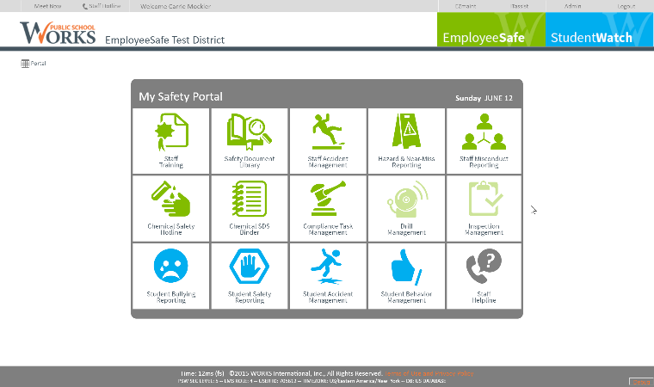

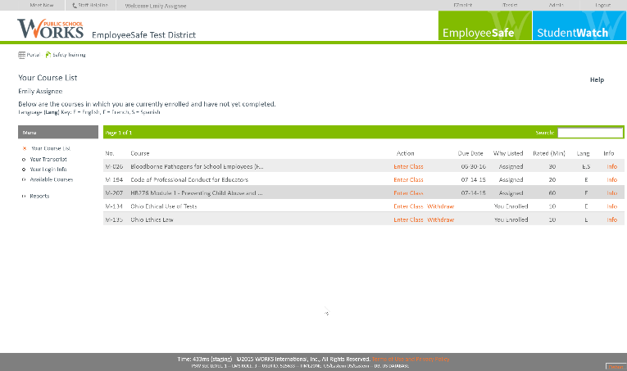

After verifying your information, you will see your course list. This is all courses that you have been assigned for this training period.

**To take a course, click on Enter Class.**

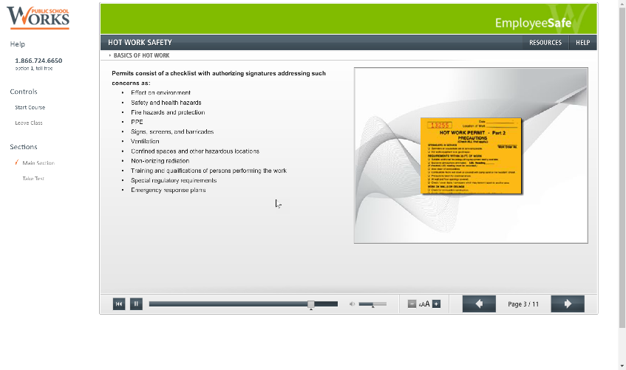

After you have entered the course, you must take the test and pass to receive credit for the course.

**To take the test, click on the Take Test link in the side bar.**

If you fail a test, you can retake the test until you obtain a passing grade. Failures do not show on your transcript.

If you have any questions or need help logging in, please call our 24/7 helpline at 1-866-724-6650 and press option 4. Or email our support team at [support@publicschoolworks.com](mailto:support@publicschoolworks.com)